主题：垃圾制造

题型：表格

The table below shows the amount of waste production (in millions of tonnes) in six different countries over a twenty-year period.

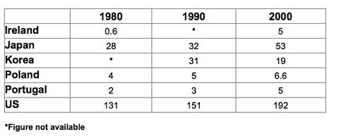

满分范文：

The chart compares the amounts of waste that were produced in six countries in the years 1980, 1990 and 2000.

In each of these years, the US produced more waste than Ireland, Japan, Korea, Poland and Portugal combined. It is also noticeable that Korea was the only country that managed to reduce its waste output by the year 2000.

Between 1980 and 2000, waste production in the US rose from 131 to 192 million tonnes, and rising trends were also seen in Japan, Poland and Portugal. Japan’s waste output increased from 28 to 53 million tonnes, while Poland and Portugal saw waste totals increase from 4 to 6.6 and from 2 to 5 million tonnes respectively.

The trends for Ireland and Korea were noticeably different from those described above. In Ireland, waste production increased more than eightfold, from only 0.6 million tonnes in 1980 to 5 million tonnes in 2000. Korea, by contrast, cut its waste output by 12 million tonnes between 1990 and 2000.